ViZDoom: A Doom-based AI Research Platform for Visual Reinforcement Learning
AI: Michał Kempka, Marek Wydmuch

Dharmik Patel (D20DCE161)
Student, Department of Computer
Engineering,
Devang Patel Institute of Advance Technology and Research,
Charusat University, Anand, Gujarat, India
Prof. Mohammed Bohara
Faculty, Department of Computer
Engineering,
Devang Patel Institute of Advance Technology and Research,
Charusat University, Anand, Gujarat,

Abstract—
The new advances in profound brain networks have
prompted compelling vision-based support learning techniques that have been utilized to get human-level regulators in Atari 2600 games from pixel information. Atari 2600 games, notwithstanding, do not look like certifiable assignments since they include non-sensible 2D conditions and the third-individual viewpoint. Here, we propose a clever proving ground stage for support learning research from crude visual data which utilizes the firstperson viewpoint in a semi-practical 3D world. The product, called ViZDoom, depends on the traditional first-individual shooter computer game, Doom. It permits creating bots that play the game utilizing the screen cushion. ViZDoom is lightweight, quick, and profoundly adjustable through an advantageous instrument of client situations. In
the exploratory part, we test the climate by attempting to learn bots for two situations: an essential move-and-shoot task and a more intricate labyrinth route issue. Utilizing convolutional profound brain networks with Q-learning and experience replay, for the two situations, we had the option to prepare skilled bots, which display human-like ways of behaving. The outcomes affirm the utility of ViZDoom as an AI research stage and infer that visual support learning in 3D sensible first-individual viewpoint conditions is plausible
Keywords—
Control modes
ViZDoom executes four control modes: I) coordinated player, ii) simultaneous observer, iii) offbeat player, and iv) nonconcurrent observer. In offbeat modes, the game runs at consistent 35 casings each second and assuming that the specialist responds too leisurely, it can miss a few edges. Then again, assuming that it settles on a choice excessively fast, it is obstructed until the following casing shows up from the motor. Accordingly, for support learning research, more helpful are the coordinated modes, in which the game motor sits tight for the leader. Thusly, the learning framework can learn at itsspeed, and it isn't restricted by any transient limitations.
Scenarios
One of the main highlights of ViZDoom is the capacity to run custom situations. This incorporates making proper guides, programming the climate mechanics ("when and how things occur"), characterizing terminal conditions (e.g., "killing a specific beast", "getting to a certain place", "kicked the bucket"), and rewards (e.g., for "killing a beast", "getting injured", "getting an article"). This component opens perpetual trial and error prospects. Specifically, it permits making a situation of a trouble which is comparable to the abilities of the surveyed learning calculations.
Depth Buffer Access
ViZDoom gives admittance to the renderer's profundity support (see Fig. 3), which might help a specialist to get the gotten visual data. This element offers a chance to test whether the learning calculations can independently become familiar with the whereabouts of the articles in the climate. The profundity data can likewise be utilized to recreate the distance sensors normal in portable robots Introduction (Heading 1)

Related work

Probably the earliest work on visual-based support learning is because of Asada et al. [4], [3], who prepared robots different rudimentary soccer-playing abilities. Different works in this region incorporate showing versatile robots with visual-based Qlearning [10], learning strategies with profound auto-encoders and clump mode calculations [19], neuroevolution for a dream based rendition of the mountain vehicle issue [6], and packed neuroevolution with intermittent brain networks for vision-based vehicle test system [17]. As of late, Mnih et al. have shown a profound Q-gaining technique for gaining Atari 2600 games from visual input [22].

To the extent that we know, until now, there have been no concentrates on that utilized the class traditional Doom FPS.Too, no past review utilized crude visual data to foster bots in first-individual point of view games with an eminent special case of the Abel's et al. work on Minecraf

methods
Making one further 3D first-individual point of view territory from scratch alone for investigation capacities would be mercifully extreme (27). as a result of the acknowledgment of the firstperson shooter kidney, we have set to utilize A being down machine on the grounds that the base for the territory. we tend to completed that it needs to meetthebackconditions
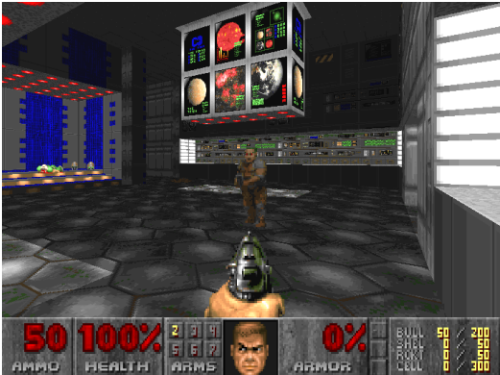
1) based on popular open-source 3D FPS game (ability to modify the code and the publication freedom)
2) lightweight (compactness and the capacity to run numerous occurrences on a solitary machine),
3) quick (the game motor ought not be the learning bottleneck),
4) all out command over the game's handling (so that the game can sit tight for the bot choices or the specialist can advance by noticing a human playing),
5) adaptable goal and delivering boundaries,
6) multiplayer games capacities (specialist versus specialist and specialist versus human),
7) simple to-utilize devices to make custom situations,
8) capacity to tie different programming dialects (preferably written in C++),
9) multi-stageconnections
To pursue the choice as per the above-recorded standards, we have investigated seven conspicuous FPS games: Shake III Arena, Doom 3, Half-Life 2, Unreal Tournament 2004, Unreal Tournament and Cube. Their correlation is displayed in Table I. A portion of the elements recorded in the table are objective (e.g., 'prearranging') and others are emotional ("code intricacy"). Memorability was assessed as the number (in huge number of) Google results (as of 26.04.2016) for phrases "game <gamename>", where <gamename> was 'destruction', 'tremor', 'half-life', 'stunning competition' or 'solid shape'. The game was thought of as low-goal proficient assuming that it was feasible to set the goal to values less than 640 × 480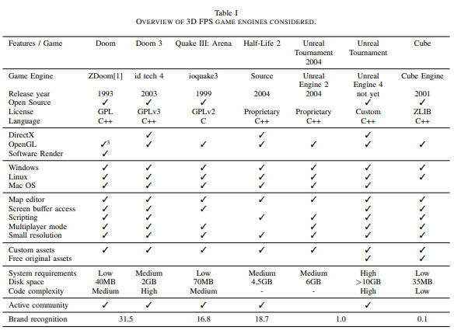
The client-server design was likewise one the explanations behinddismissal of Quake III: Arena. Shudder III likewise doesn't offer any prearranging abilities, which are crucial for make an exploration climate adaptable. The dismissal of Quake was a hard choice as it is an exceptionally respected and playable game even these days however this couldn't offset the absence of prearranging support.

dataset description
We have also checked how robust to skipcounts the agents are. For this purpose, we evaluated them using skipcounts different from ones they had been trained with. Most of the agents performed worse than with their “native” skipcounts. The least robust were the agents trained with skipcounts less than 4. Larger skipcounts resulted in more robust agents. Interestingly, for skipcounts greater than or equal to 30, the agents score better on skipcounts lower than the native ones. Our best agent that was trained with skipcount 4 was also the best.when executed with skipcount 0

discussion

The experimental tests reported in this section provide various details. The proposed structure addresses the NLU problem in comprehensive dialogue programs, model semantics through multiple Dialogue Acts and framework-like structures in a finite way. Moreover, its sequential structure, which reflects the complexity of a single function, allows to provide rich presentations throughout the network. In this regard, we can ensure that the structures successfully address the problem of multiple operations, with promising results regarding the usability and usability of the system in real-world situations.

conclusion and future work
ViZDoom is a Doom-based stage for research in visionbased support learning. It is not difficult to-utilize, exceptionally adaptable, multi-stage, lightweight, and productive. Rather than the other famous visual learning conditions like Atari 2600, ViZDoom gives a 3D, semi-practical, first-individual viewpoint virtual world. ViZDoom's API gives the client full control of the climate. Numerous methods of activity work with trial and error with various learning ideal models for example, support learning, apprenticeship picking up, learning by show, and, even the 'conventional', administered learning. The strength and adaptability of climate lie in is adaptability through the instrument of situations, which can be advantageously modified with open-source instruments

We additionally showed that visual support learning is conceivable in the 3D virtual climate of ViZDoom by performing explores different avenues regarding profound Q-learning on two situations. The consequences of the straightforward move-and-shoot situation, show that the speed of the learning framework exceptionally relies upon the number of edges the specialist is permitted to skip during the learning. We have figured out that it is beneficial to skip from 4 to 10 casings. We involved this information in the second, more involved, situation, in which the specialist needed to explore throughan antagonistic labyrinth and gather a few things and stay away from the others. Albeit the specialist couldn't track down an ideal system, it figured out how to explore the labyrinth shockingly well showing proof of a human-like way of behaving

VII. References

Zdoom wiki page. http://zdoom.org/wiki/Main Page. Accessed: 2016- 01-30.
- David Abel, Alekh Agarwal, Fernando Diaz, Akshay Krishnamurthy, and Robert E. Schapire. Exploratory gradient boosting for reinforcement learning in complex domains. CoRR, abs/1603.04119, 2016
- Minoru Asada, Shoichi Noda, Sukoya Tawaratsumida, and Koh Hosoda. Purposive behavior acquisition for a real robot by vision-based reinforcement learning. In Recent Advances in Robot Learning, pages 163–187. Springer, 1996
- Minoru Asada, Eiji Uchibe, Shoichi Noda, Sukoya Tawaratsumida, and Koh Hosoda. A vision-based reinforcement learning for coordination of soccer playing behaviors. In Proceedings of AAAI-94 Workshop on AI and A-life and Entertainment, pages 16–21, 1994.
- Nicholas Cole, Sushil J Louis, and Chris Miles. Using a genetic algorithm to tune first-person shooter bots. In Evolutionary Computation, 2004. CEC2004. Congress on, volume 1, pages 139–145. IEEE, 2004.
- Giuseppe Cuccu, Matthew Luciw, Jurgen Schmidhuber, and Faustino ¨ Gomez. Intrinsically motivated neuroevolution for vision-based reinforcement learning. In Development and Learning (ICDL), 2011 IEEE International Conference on, volume 2, pages 1–7. IEEE, 2011.
- Mark Dawes and Richard Hall. Towards using first-person shooter computer games as an artificial intelligence testbed. In KnowledgeBased Intelligent Information and Engineering Systems, pages 276–282. Springer, 2005.
- Abdennour El Rhalibi and Madjid Merabti. A hybrid fuzzy ANN system for agent adaptation in a first person shooter. International Journal of Computer Games Technology, 2008, 2008.
- A I Esparcia-Alcazar, A Martinez-Garcia, A Mora, J J Merelo, and P Garcia-Sanchez. Controlling bots in a First Person Shooter game using genetic algorithms. In Evolutionary Computation (CEC), 2010 IEEE Congress on, pages 1–8, jul 2010
- Andrew L. Maas, Awni Y. Hannun, and Andrew Y. Ng. Rectifier nonlinearities improve neural network acoustic models. In International Conference on Machine Learning (ICML), 2013.

